**PART B – Practice**

Required

a) .NET 5

b) SQL Server

c) C#

d) nUnit

e) Entity Framework

For the practical exercise, take into account the following evaluation criteria:

a) Architecture

b) Structure

c) Documentation Code

d) Best Practices

e) Manage Performance

f) Unit Test

g) Security

Build web page using .NET 5 based to next requirements:

The library “TRAVEL” requires software to manage inventory, your mission is create an app for see the books and details per book, please use the following MER

MER

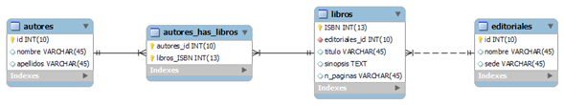

Release

Send solution with project in zip file or upload from github or other similar site. Attach database backup. if is necessary specify steps for run project when download.

**GOOD LUCK!**